Arrays (std::array first)
http://www.cplusplus.com/reference/array/array/

What is it, how they work?
An array is a series of numbers/letters/symbols that are the same type (int, float, double, char etc…) that are held in a container in a strict linear sequence. An array does not hold any information other than the information that it is assigned. The way to create an array would look like:
char Scott [5];
The char is the data type, Scott is the name of the array (you can be as creative as you want with the name), and the [5] is the size of the array. So “char Scott [5];” can hold 5 pieces of data that are the same data type.
You can also initialize values inside the array immediately like any other variable. The way to create an array with preset values would look like:
char Scott[5] = {‘S’, ‘c’, ‘o’, ‘t’, ‘t’};
int Scott[5] = {99, 5, 1, 22, 7};
Arrays hold data by storing each value in an index of the array. An index is just a slot in the array that stores one piece of data that is the same type as the array. The indexes of arrays start with 0 and end with the array size minus 1. So in “char Scott[5]” the first index would be Scott[0] and the last index would be Scott[4]. The data stored in the array with the respective indexes would look like this:
Scott[0] would hold an “S”
Scott[1] would hold a “c”
Scott[2] would hold an “o”
Scott[3] would hold a “t”
Scott[4] would hold a “t”

Matrices
What is it, how they work?
A matrix is the same thing as an array, but is an “array of arrays” (so looks like a box) matrices take arrays to a 2 dimensional field and more. The way matrices work is the same way as arrays but with more []’s. With a 3D matrix the first [ ] is referring to the row. The second [ ] is referring to the columns. The third [ ] would be the length. When you have any more[ ]’s there is no way we can think in the 4 dimensional to name what it is measuring, but you can still fill a 4D matrix, etc…
Diagram of Matrices:
int array[3];
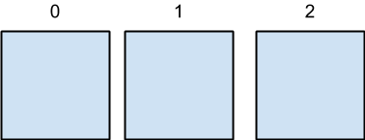
int array[3][3];
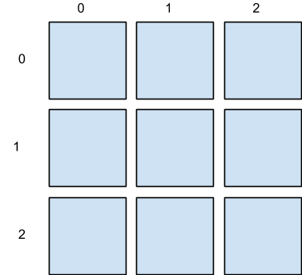

int array[3][3][3];
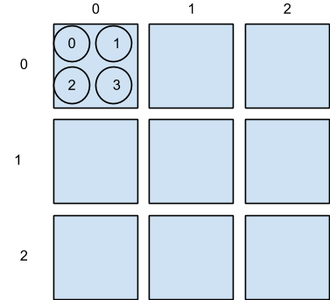

The way you fill a matrix is just like you would fill an array. You can initialize the matrix like an array it or have the user input values for it. The way you fill a matrix by initialization looks like:
#include <iostream>
using namespace std;
int main()
{
int rich[3][3] = {{1, 2, 3}, {4, 5, 6}, {7, 8, 9}}; //filling matrix with set numbers
cout << rich[0][0] << endl << endl; //first number
cout << " " << rich[2][2]; //last number
return 0;
}

When this code is ran, it will output the first and last values in the matrix, which are 1 and 9 respectively.
This is what code might look like when the matrix is filled by the user:
#include <iostream>
#include<fstream>
using namespace std;
int jimmy(istream& giveme=cin)
{
int x;
cout << "fill me and hit enter after each int you enter";
giveme >> x;// inputting to matrix
return x;
}
int main()
{
int bob[3][3]; //creates a 3 by 3 matrix
for(int i = 0; i < 3; i++) //This loops through rows of the array
{
for(int j = 0; j < 3; j++) //This loops through the columns of the array
{
bob[i][j] = jimmy();
}
}
for(int i=0; i<3; i++) //This loops on the rows.
{
for(int j=0; j<3; j++) //This loops on the columns
{
cout << bob[i][j] << " ";
}
cout << endl;
}
return 0;
}

When you create an array, eventually you may want to print it out, right? Well outputting the contents of an array isn’t as simple as using “cout << ” then calling the array. Unfortunately you have to use another “for” loop to do so. Below you will see that I have created an array that sorts the contents of a predefined array and then outputs the contents in order from least to greatest.

#include <iostream>
#include <cstdlib>

using namespace std;

void sort(int t[16]); // declaration of void sort function

int main() // main function
{
int t[16]={4,3,15,13,12,18,9,7,5,2,1,10,19,20,22,15}; // initializes a 16 element array
named 't'
sort(t); // function call
}

void sort(int t[16]) // sorts array t[16] and is passed the information from the array to the function
{
for (int i= 0; i < 16; i++) // increments up through the code
{
for(int j = i; j>0; j--) // increments down through the code to double check whether or
not swapped variable is larger
{
if (t[j]>t[j-1]) // condition statement that determines if the 'j'-th indexed
element is > the previous or [j-1]
swap(t[j], t[j-1]); // if aforementioned condition is true, swap the variables
else
break; // if aforementioned condition is wrong break away from code and
continue to next element
}
}
for (int k = 0; k < 16; k++) // sets another variable aside 'k' and increments through the
sorted array
{
cout << t[k] << endl; // finds the 'k'-th element within array 't[]' and outputs the value to
screen
}
}

Created by James Verderico on 1/17/13. Copyright © 2013 James Verderico. All rights reserved.

